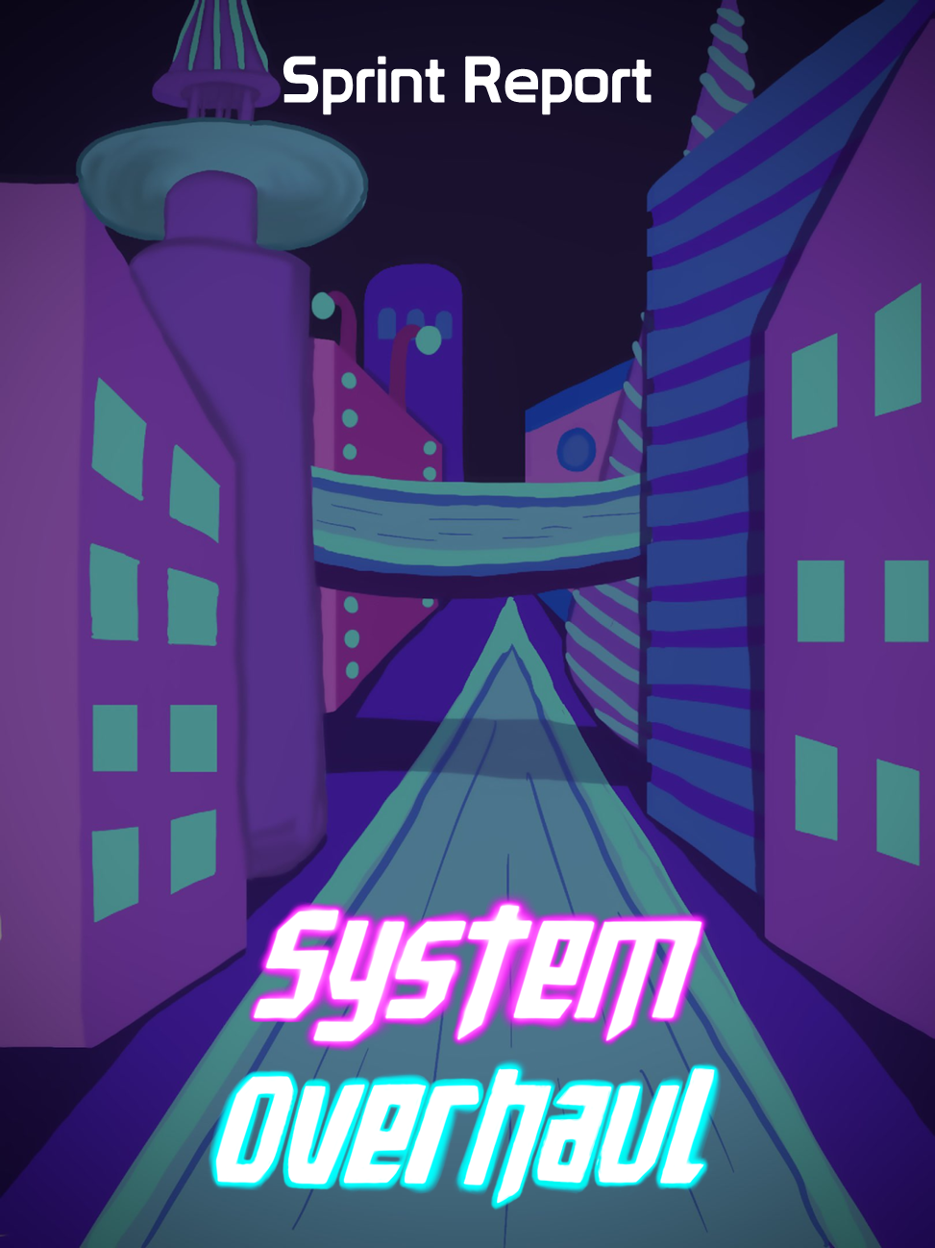





**Table of Contents**

**Previous Week** **2**

Sprint Backlog 2

Review 2

**Next Week** **3**

Sprint Backlog 3

Notes 3

# Previous Week

## Sprint Backlog

| **Tasks** | **Time Needed** | **Responsible** | **Priority** | **Stage** |
| --- | --- | --- | --- | --- |
| Melee Enemies | 2 Days | Gonçalo | High | Completed |
| Ranged Enemies | 2 Days | Sofia | High | Completed |
| Puzzles | 2 Hours | All | High | Completed |
| Collect Chips | 20 minutes | Gonçalo | Normal | Completed |
| Check Points | 30 minutes | Gonçalo | Normal | Completed |
| Upgrades | 1 Day | All | Low | Completed |
| Player Melee Attack (redo) | 4 hours | Sofia | High | Completed |
| Particle System in Projectiles | 1 hour | Sheehan | Normal | Completed |

* 1. Objectives

Our objectives were completed successfully.

We will continue working on the melee and ranged enemy and give them more complexity, but the things that we plan to do on them are done.

No tasks were planned from the design part.

## Review

In the player melee attack we also implemented a simple animation on the sword.

In the Melee enemy and Ranged enemy tasks we wanted to implement something more complex (even though the basics are working) so it took more time than what was expected and it got delayed, these tasks will be continued in sprint 3. Also after putting the code together the player melee attack doesn’t work with the switch weapons and the ranged attack code, this task will be redone in sprint 3.

The rest of the tasks were done successfully and were finished in time.

No tasks were planned from the design part.

# Next Week

In the “Required for CG & AI” backlog our tasks with higher priority are the following:

| **Tasks** | **Time Estimate** |
| --- | --- |
| Friendly NPCs | 3 Days |
| Player Hurt Shader | 2 Days |
| Improve Ranged Enemy | 2 Days |
| Improve Melee Enemy | 2 Days |
| Improve the NPCs | 2 Days |

In the “Coding” backlog our tasks with higher priority are the following:

| **Tasks** | **Time Estimate** |
| --- | --- |
| Fix Bugs | ½ Day |
| Level Design | 1 Day |
| Pause Menu | ½ Day |
| Main Menu | ½ Day |

In the “3D Models & Animations” backlog the priority of the tasks didn’t change

In the “Docs” backlog the priority of the tasks didn’t change

In the “UI / 2D / Sounds” backlog the priority of the tasks didn’t change

## Sprint Backlog

| **Tasks** | **Time Estimate** | **Responsible** | **Priority** | **Stage** |
| --- | --- | --- | --- | --- |
| Fix Bugs | ½ Day | All | High | Open |
| Plan City Layout | 1 Day | All | High | Open |

## Notes

As we have the game jam next week we won’t be planning a lot of tasks.